[12:18, 9/8/2020] Marcos Amorim: https://186.234.209.180:99/

[12:18, 9/8/2020] Marcos Amorim: Admin

[12:18, 9/8/2020] Marcos Amorim: AntaGordaAlegre12#$

AntaGordaAlegre123#$

Other tests

Test 1

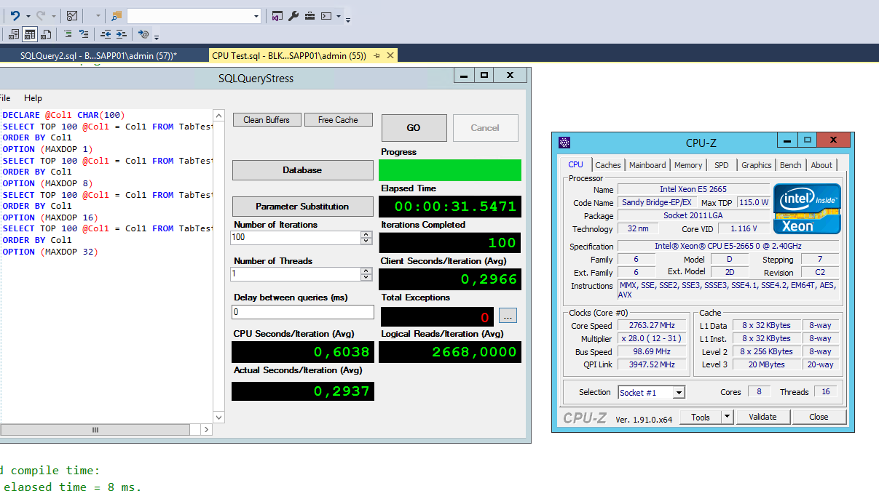

USE tempdb

GO

IF OBJECT_ID('TabTest1') IS NOT NULL

DROP TABLE TabTest1;

CREATE TABLE TabTest1(Col1 CHAR(500));

INSERT INTO TabTest1

SELECT TOP 10000

CONVERT(CHAR(100), 'Test, fixed data to be used on test') AS Col1

FROM master.dbo.sysobjects A,

master.dbo.sysobjects B,

master.dbo.sysobjects C,

master.dbo.sysobjects D

OPTION (MAXDOP 1);

UPDATE STATISTICS TabTest1 WITH ROWCOUNT = 1000000, PAGECOUNT = 100000

GO

-- Quick scan to make sure all pages are in cache

SET STATISTICS IO ON

SELECT COUNT(*) FROM TabTest1

SET STATISTICS IO OFF

GO

SET STATISTICS IO, TIME ON

GO

DECLARE @Col1 CHAR(100)

SELECT TOP 100 @Col1 = Col1 FROM TabTest1

ORDER BY Col1

OPTION (MAXDOP 1)

SELECT TOP 100 @Col1 = Col1 FROM TabTest1

ORDER BY Col1

OPTION (MAXDOP 8)

SELECT TOP 100 @Col1 = Col1 FROM TabTest1

ORDER BY Col1

OPTION (MAXDOP 16)

SELECT TOP 100 @Col1 = Col1 FROM TabTest1

ORDER BY Col1

OPTION (MAXDOP 32)

GO

SET STATISTICS IO, TIME OFF

GO

/*

SQL Server parse and compile time:

CPU time = 8 ms, elapsed time = 8 ms.

Table 'TabTest1'. Scan count 1, logical reads 667, physical reads 0, read-ahead reads 0, lob logical reads 0, lob physical reads 0, lob read-ahead reads 0.

SQL Server Execution Times:

CPU time = 203 ms, elapsed time = 198 ms.

Table 'TabTest1'. Scan count 9, logical reads 667, physical reads 0, read-ahead reads 0, lob logical reads 0, lob physical reads 0, lob read-ahead reads 0.

SQL Server Execution Times:

CPU time = 172 ms, elapsed time = 47 ms.

Table 'TabTest1'. Scan count 17, logical reads 667, physical reads 0, read-ahead reads 0, lob logical reads 0, lob physical reads 0, lob read-ahead reads 0.

SQL Server Execution Times:

CPU time = 79 ms, elapsed time = 24 ms.

Table 'TabTest1'. Scan count 33, logical reads 667, physical reads 0, read-ahead reads 0, lob logical reads 0, lob physical reads 0, lob read-ahead reads 0.

SQL Server Execution Times:

CPU time = 93 ms, elapsed time = 22 ms.

SQL Server parse and compile time:

CPU time = 0 ms, elapsed time = 0 ms.

Completion time: 2020-09-08T18:46:50.5081853-03:00

*/

Test 2

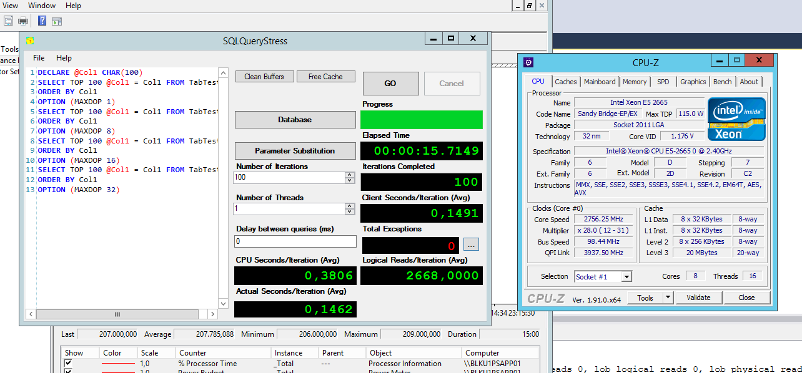

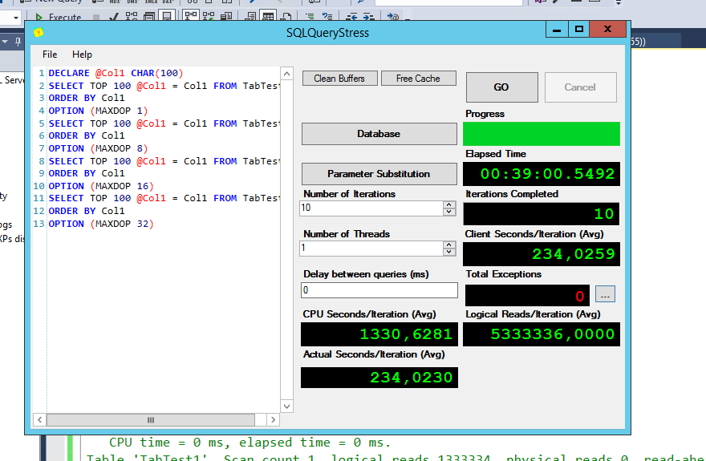

USE tempdb

GO

IF OBJECT_ID('TabTest1') IS NOT NULL

DROP TABLE TabTest1;

CREATE TABLE TabTest1(Col1 CHAR(500));

INSERT INTO TabTest1

SELECT TOP 20000000

CONVERT(CHAR(100), 'Test, fixed data to be used on test') AS Col1

FROM master.dbo.sysobjects A,

master.dbo.sysobjects B,

master.dbo.sysobjects C,

master.dbo.sysobjects D

OPTION (MAXDOP 1);

GO

-- Quick scan to make sure all pages are in cache

SET STATISTICS IO ON

SELECT COUNT(*) FROM TabTest1

SET STATISTICS IO OFF

GO

SET STATISTICS IO, TIME ON

GO

DECLARE @Col1 CHAR(100)

SELECT TOP 100 @Col1 = Col1 FROM TabTest1

ORDER BY Col1

OPTION (MAXDOP 1)

SELECT TOP 100 @Col1 = Col1 FROM TabTest1

ORDER BY Col1

OPTION (MAXDOP 8)

SELECT TOP 100 @Col1 = Col1 FROM TabTest1

ORDER BY Col1

OPTION (MAXDOP 16)

SELECT TOP 100 @Col1 = Col1 FROM TabTest1

ORDER BY Col1

OPTION (MAXDOP 32)

GO

SET STATISTICS IO, TIME OFF

GO

/*

SQL Server parse and compile time:

CPU time = 0 ms, elapsed time = 0 ms.

SQL Server Execution Times:

CPU time = 0 ms, elapsed time = 0 ms.

SQL Server parse and compile time:

CPU time = 0 ms, elapsed time = 0 ms.

SQL Server Execution Times:

CPU time = 0 ms, elapsed time = 0 ms.

SQL Server parse and compile time:

CPU time = 0 ms, elapsed time = 0 ms.

Table 'TabTest1'. Scan count 1, logical reads 1333334, physical reads 0, read-ahead reads 0, lob logical reads 0, lob physical reads 0, lob read-ahead reads 0.

(1 row affected)

SQL Server Execution Times:

CPU time = 153875 ms, elapsed time = 153904 ms.

SQL Server parse and compile time:

CPU time = 0 ms, elapsed time = 1 ms.

Table 'TabTest1'. Scan count 9, logical reads 1333334, physical reads 0, read-ahead reads 0, lob logical reads 0, lob physical reads 0, lob read-ahead reads 0.

(1 row affected)

SQL Server Execution Times:

CPU time = 194294 ms, elapsed time = 24402 ms.

SQL Server parse and compile time:

CPU time = 0 ms, elapsed time = 1 ms.

Table 'TabTest1'. Scan count 17, logical reads 1333334, physical reads 0, read-ahead reads 0, lob logical reads 0, lob physical reads 0, lob read-ahead reads 0.

(1 row affected)

SQL Server Execution Times:

CPU time = 758154 ms, elapsed time = 47579 ms.

SQL Server parse and compile time:

CPU time = 0 ms, elapsed time = 1 ms.

Table 'TabTest1'. Scan count 33, logical reads 1333334, physical reads 0, read-ahead reads 0, lob logical reads 0, lob physical reads 0, lob read-ahead reads 0.

(1 row affected)

SQL Server Execution Times:

CPU time = 452454 ms, elapsed time = 14533 ms.

SQL Server parse and compile time:

CPU time = 0 ms, elapsed time = 0 ms.

Completion time: 2020-09-08T18:56:22.5622541-03:00

SQL Server parse and compile time:

CPU time = 0 ms, elapsed time = 0 ms.

Table 'TabTest1'. Scan count 1, logical reads 1333334, physical reads 0, read-ahead reads 0, lob logical reads 0, lob physical reads 0, lob read-ahead reads 0.

(1 row affected)

SQL Server Execution Times:

CPU time = 153140 ms, elapsed time = 153162 ms.

Table 'TabTest1'. Scan count 9, logical reads 1333334, physical reads 0, read-ahead reads 0, lob logical reads 0, lob physical reads 0, lob read-ahead reads 0.

(1 row affected)

SQL Server Execution Times:

CPU time = 197610 ms, elapsed time = 24825 ms.

Table 'TabTest1'. Scan count 17, logical reads 1333334, physical reads 0, read-ahead reads 0, lob logical reads 0, lob physical reads 0, lob read-ahead reads 0.

(1 row affected)

SQL Server Execution Times:

CPU time = 268581 ms, elapsed time = 16918 ms.

Table 'TabTest1'. Scan count 33, logical reads 1333334, physical reads 0, read-ahead reads 0, lob logical reads 0, lob physical reads 0, lob read-ahead reads 0.

(1 row affected)

SQL Server Execution Times:

CPU time = 452699 ms, elapsed time = 14465 ms.

SQL Server parse and compile time:

CPU time = 0 ms, elapsed time = 0 ms.

Completion time: 2020-09-08T19:00:36.5905151-03:00

*/

